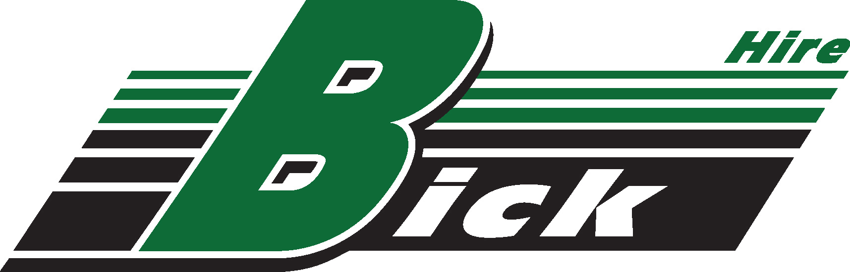

Bick Hire Pty Ltd
ABN 28 100 968 885 Civil, Plant & Truck Hire Ph: 0265563755
Lot 2 Pacific Highway Fax:02 65563127
COOPERNOOK NSW 2426 bickhire.admin@bigpond.com

- Bick Hire Policy – Safety
Version 2
Date 20th April 2016

At Bick Hire Pty Ltd our Work Health, Safety and Rehabilitation policy is based on a belief that the well-being of people employed at work, or people affected by our work, is a major priority and must be considered during all work performed on our behalf.

People are our most important asset and their health and safety is our greatest responsibility. The public shall be given equal priority to that of our employees.

The objectives of our Safety Policy are:
- To achieve an accident free workplace.
- To make health and safety an integral part of every managerial and supervisory position.
- To ensure health and safety is considered in all planning and work activities.
- To involve our employees in the decision making processes through regular communication, consultation and training.
- To provide a continuous program of education and learning to ensure that our employees work in the safest possible manner.
- To identify and control all potential hazards in the workplace through hazard identification and risk analysis.
- To ensure all potential accident/incidents are controlled and prevented.
- To provide effective injury management and rehabilitation for all employees.

The success of our health and safety management is dependent on:
- Pro-active planning of all work activities with due consideration given to implementing occupational health and safety (OHS) controls that are suitable to each given situation.
- Understanding the total work process and associated OHS risks.
- Ensuring the work team is totally committed to achieving our objectives.
- Ensuring that open and honest communication exists between management and all employees.

Bick Hire will always comply with :
Work Health and Safety ACT 2011
Work Health and Safety Regulations 2011
All Road Rules
There are several key documents that are fundamental to the safe operation of Bick Hire machines on construction sites, under the control and supervision of Contractors. All Bick Hire employees will be provided with these safety documents and are invited to participate in their further development to ensure their relevance to the tasks being performed.
These documents include:
- All Bick Hire Policies, specifically:
  - This Safety Policy
  - Quality Statement
  - Fatigue Management
  - Site Supervision
  - Reporting and Communication
  - Mobile Phone use
  - On Site Supervision

- Bick Hire Work Health and Safety Plan
- Job site Work Health and Safety Plan
- Safe Work Method Statement (SWMS)
- Plant Risk Assessment
- Site location work Packs and daily work schedules
- Any other site specific requirements.

As an owner and operator of large and heavy vehicles a major issue for Bick Hire is vehicle maintenance. Bick Hire will maintain its fleet of vehicles in a Road worthy state at all times. Any repairs needed to machinery to ensure its continued safe operation will be carried out as soon possible in compliance with the law and site requirements.

Scott Frayne, Director

